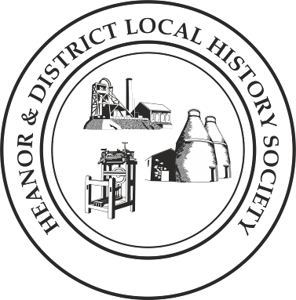We want your memories! As part of an ongoing project, the Heanor & District Local History Society wants to hear from YOU.
We would like to establish a collection of people’s memories about the area - it can be from any period, and from any part of the district. And ANY subject - whether home life, work life, shopping, leisure. It doesn’t matter how trivial you may think your reminiscences are, they will help form part of a much bigger picture, which we can use to assist our future research, publications and newsletters.
This is nothing new of course; we have always asked for this from our members, but have now decided to use this method to try to prompt people to give information on specific issues.
This month’s topic is: the Fun of the Fair!
This time we want to look at what you remember about the fairs or wakes that visited the area. Yes, we assume that most people will tell us about Heanor Fair, but we are just as interested in other travelling fairgrounds which visited Codnor, Langley Mill, and other places in the area.

How to pass the information onto us:
- If you normally attend our meetings, just fill in the form and hand it back at the next meeting.
- If you don’t attend our meetings, then you can send us an email with the information (mail@heanorhistory.org.uk), or post it to the Society at 12 Walton Court, West Hallam, Ilkeston, DE7 6NS.
We would rather that you didn’t send us information anonymously, but nobody’s name will be published unless you have specifically given us permission to do so. In particular, we WILL NOT publish anything which of a personal or potentially sensitive nature.
Name | Address
Telephone
Email address
Are you willing for your name to be linked to any information supplied? |  | Yes / No
Would you be prepared to discuss this or related information further? |  | Yes / No

P.T.O.

We want you to think back to past visits to the fair; try and concentrate on one specific time-period – the one where your memories are most vivid.
When (decade) can you best remember the fair from? Were you a child or adult at that time?
If not the fair on Heanor Market Place, where was it set up?
How long did the fair stay for? How many times did you visit it, and how long were your visits?
Please describe the atmosphere as you recall it.
What can you remember about the people who worked on the fairground?
What fairground rides can you remember? Which was your favourite, and why?

What about other stalls and booths? Which stand out in your memory?
Please use a separate sheet if necessary. If you have any photographs of fairgrounds in the Heanor area, then please let us know. Thank you

